PillSync

Team Members:
Dushyant Singh Sisodiya
Jangam Keerthana
Duggirala Deepika
Sujata Behera
Jyotiprangya Patra

Table of Contants

- INTRODUCTION

2.PROBLEM STATEMENT

3.OBJECTIVES

4 . PROPOSED SYSTEM AND WORKFLOW

5. TECHNOLOGY STACK

6. FUNCTIONALITIES

7. UI SCREENSHOTS

8. CONCLUSION

9. FUTURE ENHANCEMENTS

Intelligent Medicine Reminder and Medication Tracking Platform

1. INTRODUCTION
PillSync is an AI-Driven Medication Recognition and Personalized Reminder Platform designed to make medication management easier and more organized. It helps users manage medicines, schedule dosages, track medication adherence, and monitor medicine stock levels. The platform uses Optical Character Recognition (OCR) technology to extract text from uploaded prescription images, reducing manual data entry.
The key features of PillSync include a patient dashboard, medicine management, prescription scanning, personalized medication reminders, dosage tracking, medication history, and adherence monitoring. These features help users organize their medication schedules, monitor medicine availability, reduce manual effort, and maintain a consistent medication routine. Overall, PillSync provides a user-friendly platform for convenient and efficient medication management.

2. PROBLEM STATEMENT
Managing multiple medications can be challenging for patients due to difficulties in remembering dosage schedules, tracking medication history, and monitoring medicine stock. Manual entry of prescription details can also be time-consuming and may lead to errors. Additionally, patients may find it difficult to monitor their medication adherence and maintain an organized medication routine.
To address these challenges, PillSync aims to provide a centralized platform that uses OCR technology for prescription text extraction and offers medication management, personalized reminders, dosage tracking, and adherence monitoring. The system helps users manage their medicines efficiently, reduce manual effort, and follow their prescribed medication schedules more conveniently.

3. OBJECTIVES
The main objective of the PillSync project is to simplify medication management through an intelligent and user-friendly platform.
The key objectives are:

- Medicine Management: To help users add, view, and manage their medication details.
- OCR-Based Recognition: To extract medicine-related text from uploaded prescription images.
- Personalized Reminders: To help users follow their prescribed medication schedules.
- Medication Tracking: To record medication doses and monitor adherence.
- Stock Monitoring: To track medicine quantities and identify when refills may be needed.
- Medication History: To maintain organized records of medication activities.
- User-Friendly Dashboard: To provide easy access to medication details, schedules, and adherence information.
Overall, PillSync aims to reduce manual effort, improve medication organization, and help users manage their prescribed medicines more conveniently.

4. PROPOSED SYSTEM AND WORKFLOW
4.1 Proposed System
PillSync is a web-based medication management platform designed to help users organize and manage their medicines efficiently. The proposed system integrates medicine management, OCR-based prescription recognition, medication scheduling, adherence tracking, and medicine stock monitoring into a single application.
The system provides a user-friendly dashboard where users can view their medication details, scheduled doses, and medicine availability. OCR technology extracts text from uploaded prescription images, helping reduce manual data entry. The platform also supports medication history and personalized reminders to help users follow their prescribed medication schedules.
The frontend communicates with backend APIs to process user requests and retrieve or update medication information. The system aims to improve convenience, organization, and medication tracking.
4.2 System Workflow
The workflow of PillSync consists of the following steps:
- User Authentication: The user logs in to the application to access their medication information.
- Dashboard Access: The system displays an overview of medicines, scheduled doses, adherence information, and stock levels.
- Medicine Management: The user can add, view, and manage medicine details, including dosage, frequency, and stock quantity.
- Prescription Scanning: The user uploads a prescription image, and the OCR module extracts the text for review.
- Medication Scheduling: The user manages medication schedules according to the prescribed instructions.
- Dose Tracking: The system records medication statuses and uses the available records to calculate adherence.
- Data Processing: The frontend communicates with backend APIs, which process requests and interact with the database as required.
- Display of Results: The application presents medication details, schedules, and tracking information through the dashboard and relevant modules.
The workflow helps bring medication-related information together in one platform, making it easier for users to manage their daily medication routines.
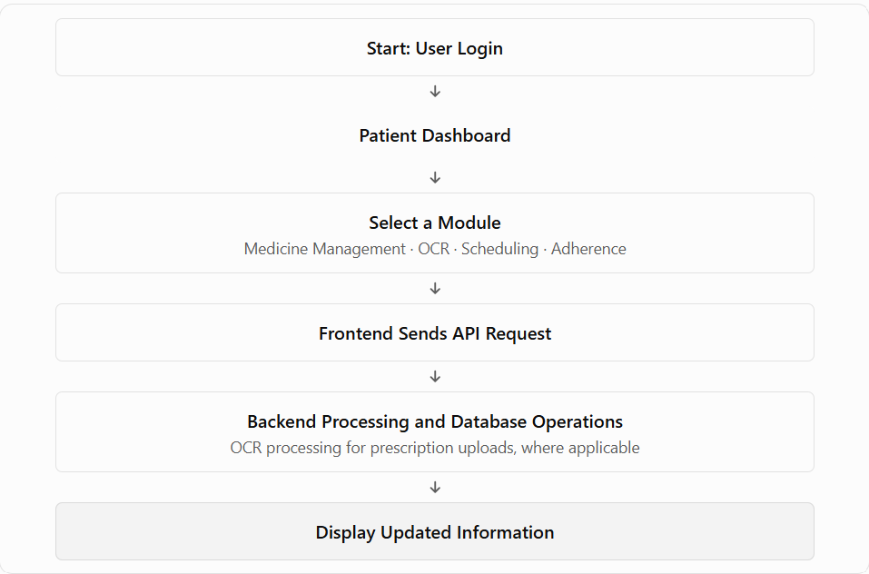
5. TECHNOLOGY STACK
PillSync uses modern web technologies to develop a user-friendly medication management platform. The technology stack supports the frontend interface, backend communication, data Used to build interactive user interfaces, including the patient dashboard, medicine management, medication schedules, and OCR result pages.storage, prescription text recognition, and deployment.
5.1 Frontend Technologies
- React.js:
- HTML5: Used to structure the web pages.
- CSS / Tailwind CSS: Used to style the application and create a responsive layout.
- JavaScript: Used to handle user interactions, form validation, and dynamic updates.
- Axios: Used to send HTTP requests from the frontend to backend APIs.
5.2 Backend Technologies
- Backend Framework: Handles application logic, API requests, and medication-related operations.
- REST APIs: Enable communication between the frontend and backend for retrieving and updating information.
- JWT Authentication: Used to authenticate users and access protected endpoints, where configured.
5.3 Database
- The database stores relevant application information, such as user details, medicine records, medication schedules, and dose history. The specific database depends on the backend configuration used by the team.
5.4 OCR Technology
Optical Character Recognition (OCR) is used to extract text from uploaded prescription or medicine images. The extracted text can be displayed to users for review before they enter or save medication details.
5.5 Development and Deployment Tools
- Visual Studio Code: Used for writing and editing code.
- Git and GitHub: Used for version control and team collaboration.
- Render: Used to deploy the PillSync frontend and make it accessible through a live URL.
6. FUNCTIONALITIES
PillSync provides several functionalities to simplify medication management and help users organize their daily medication routines.
6.1 Patient Dashboard
The dashboard displays important medication information, including active medicines, today's scheduled doses, adherence statistics, upcoming doses, and medicine stock details.
6.2 Medicine Management
Users can add and view medicines along with details such as medicine name, dosage, frequency, and available stock. This module helps users maintain organized medication records.
6.3 OCR-Based Prescription Recognition
The system allows users to upload prescription or medicine images. OCR technology extracts text from the uploaded image, enabling users to review the extracted information before entering or saving medicine details.
6.4 Medication Scheduling
Users can create and view medication schedules by specifying the medicine, frequency, scheduled time, and applicable dates. This helps organize medication routines according to prescribed instructions.
6.5 Medication Reminders
The reminder module is designed to help users keep track of scheduled medication times and follow their prescribed routines.

6.6 Medication Adherence Tracking
The system records medication dose statuses and displays adherence information based on available medication records. This helps users review their medication-taking patterns.
6.7 Medicine Stock Monitoring
Users can monitor the available quantity of medicines and their refill thresholds. This helps identify medicines that may need replenishment.
6.8 Medication History
The medication history module helps users review recorded medication activities and maintain organized records of their medication routines.
6.9 User Profile and Settings
Users can access their profile information and available application settings to manage their account and preferences.
Overall, these functionalities aim to provide a centralized, user-friendly platform for managing medicines, organizing schedules, monitoring stock, and tracking medication activities.
7. UI SCREENSHOTS
The PillSync application provides a user-friendly interface that allows users to manage their medications, view schedules, monitor medicine stock, and access medication-related information. The following screenshots illustrate the main user interface pages of the application.

7.1 Login Page
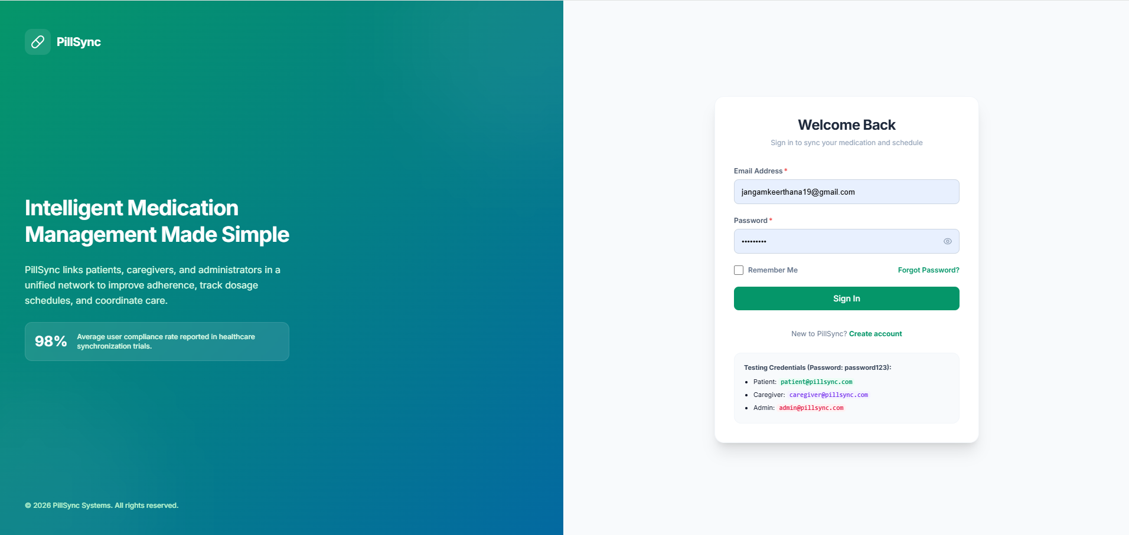

7.2 Patient Dashboard
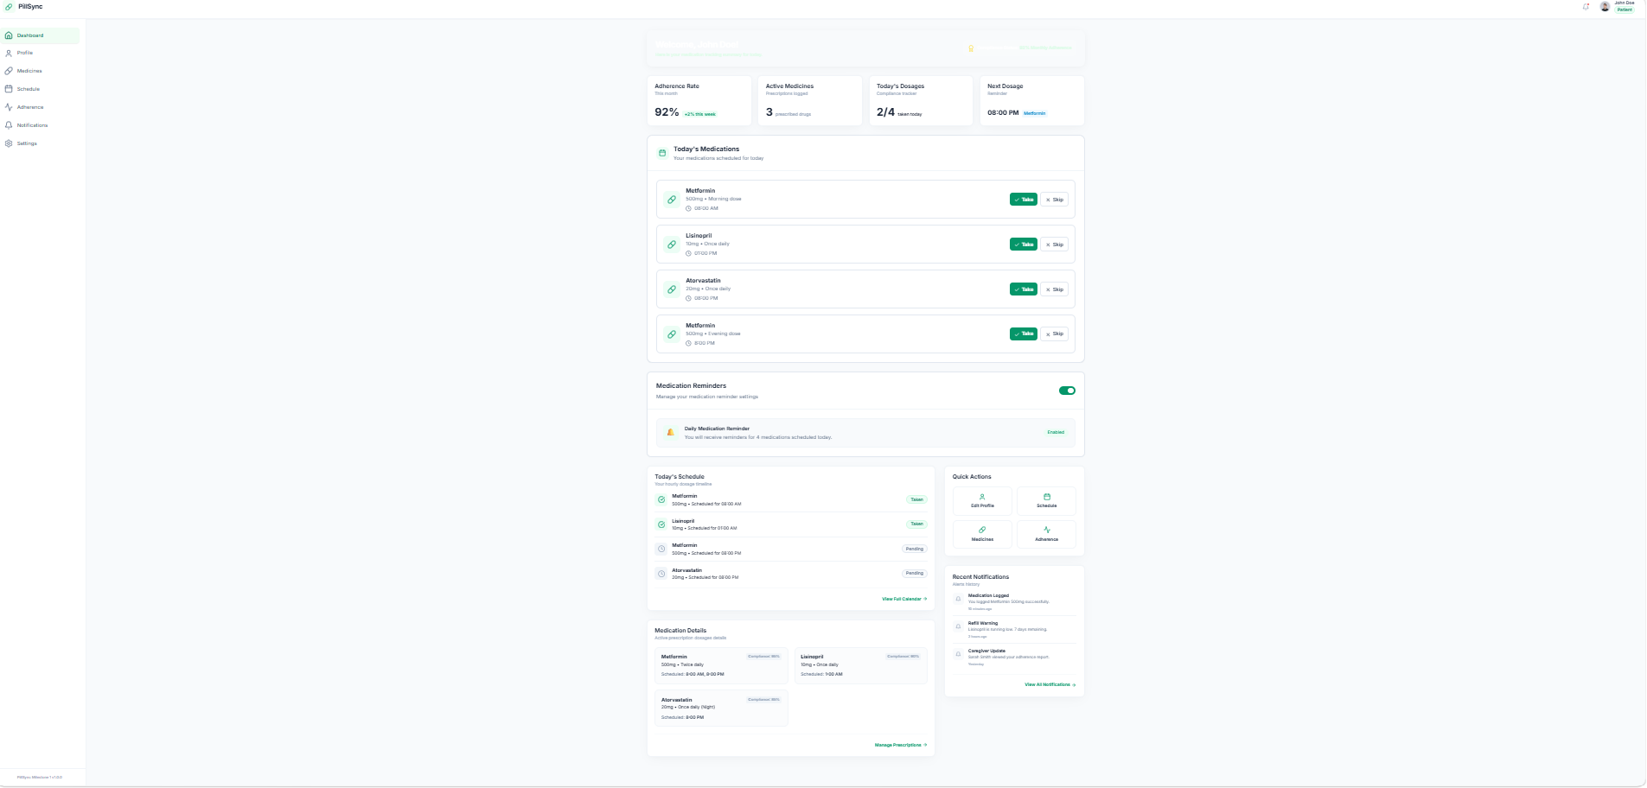

Figure 7.2: Patient Dashboard
The dashboard displays an overview of active medicines, today's dosages, medication adherence, upcoming doses, and medicine stock information. It provides quick access to the main modules of the application.

7.3 OCR Prescription Recognition

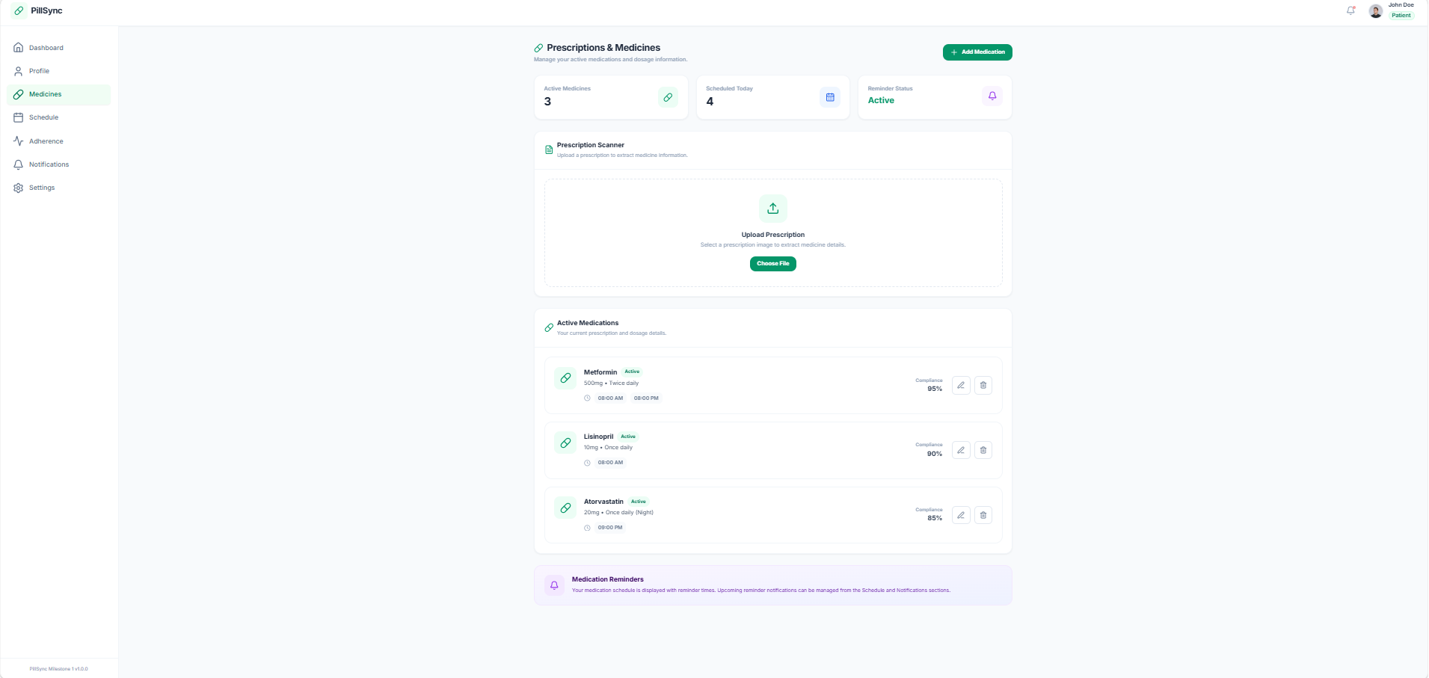
Figure 7.3: OCR Prescription Recognition Interface
This interface allows users to upload prescription images and view the text extracted using Optical Character Recognition (OCR). Users can review the extracted information before entering or saving medication details.
7.4 Medication Adherence

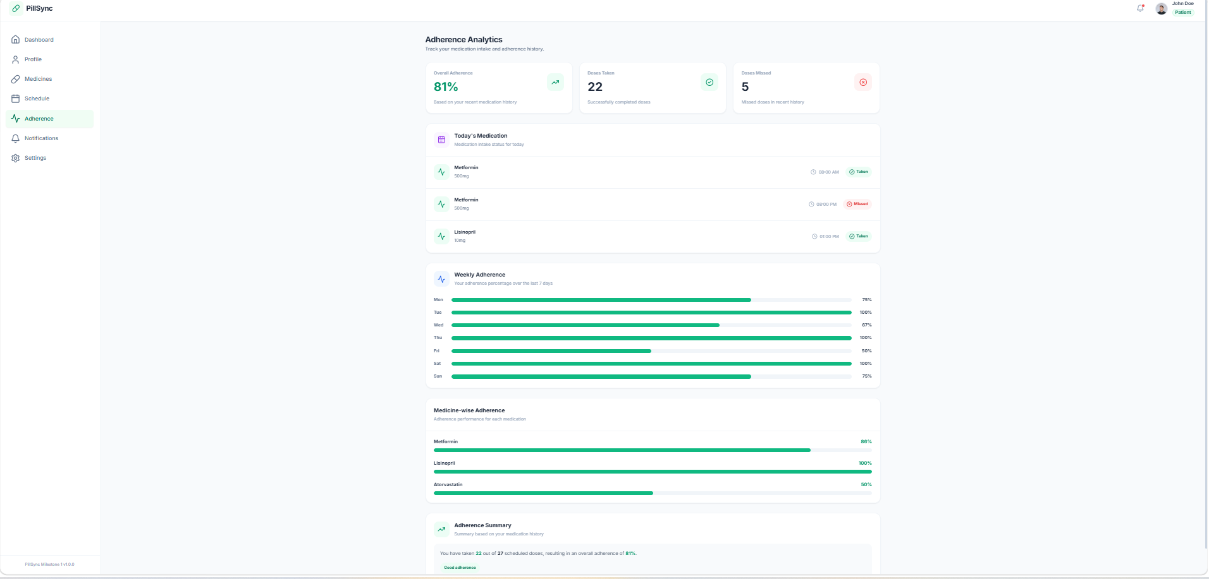
Figure 7.4: Medication Adherence Interface
This page presents medication adherence information based on recorded dose data, helping users review their medication-taking patterns.
7.5 Notifications
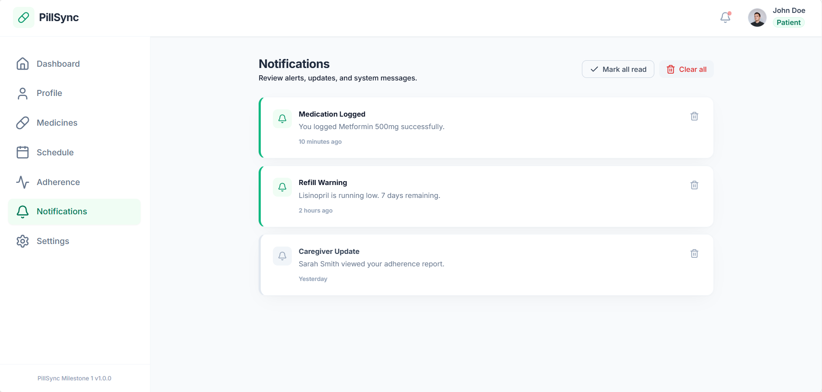
Figure 7.5: Notification

Live Project URL: https://pillsync-frontend-5wt4.onrender.com

Deployment Platform: Render
The PillSync frontend is deployed on Render, allowing users and reviewers to access the application through a web browser. The application communicates with the configured backend APIs for supported functionalities.

8. CONCLUSION
PillSync is an AI-Driven Medication Recognition and Personalized Reminder Platform developed to simplify medication management. It provides features such as medicine management, prescription text recognition using OCR, medication scheduling, adherence tracking, and medicine stock monitoring. The platform brings these functionalities together in a single user-friendly application, helping users organize their medication routines and reduce manual effort. This project also demonstrates how AI-based techniques and web technologies can be used to address real-world healthcare challenges.
9. FUTURE ENHANCEMENTS
The following enhancements can improve the functionality and usability of PillSync in the future:
- Advanced OCR Recognition: Improve the accuracy of medicine name and dosage extraction from different prescription formats.
- Smart Notifications: Implement timely push notifications and customizable medication reminders.
- Caregiver Monitoring: Enhance caregiver access to medication schedules and adherence information with appropriate permissions.
- Detailed Reports: Generate downloadable medication history and adherence reports.
- Improved Adherence Tracking: Provide more detailed summaries and visualizations based on recorded medication doses.
- Mobile Application: Develop a mobile version for easier access and medication reminders on the go.
- Enhanced Security: Strengthen the protection of user information through secure authentication and access control.
These enhancements aim to make PillSync more reliable, accessible, and useful for medication management.

